**Setting Up Application**

**Environment Docker Installation**

|  |  |
| --- | --- |
| Date | 10 Nov 2022 |
| Team ID | PNT2022TMID11845 |
| Project Name | Smart Fashion Recommender Application |

**Step 1:**

Go the official Docker website:

<https://docs.docker.com/desktop/install/windows-install/>

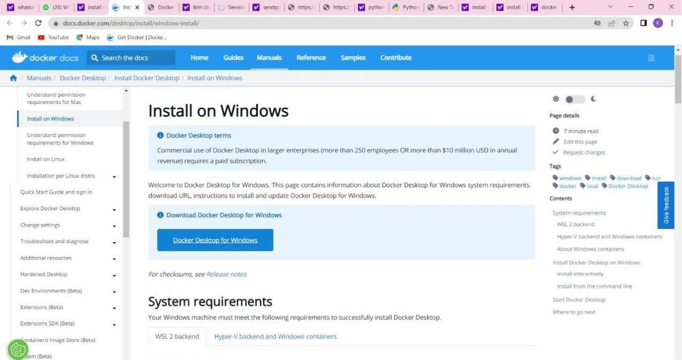

**Step 2:**

Click that button (Docker Desktop for Windows) and download will start and it takes few minutes to complete.

**Step 3:**

Go to downloads in browser (or) type **ctrl + J**, it will navigate to download page and double-click the particular docker file.

**Step 4:**

Now Installation is complete. This icon was added in your desktop. Double-click the icon to start the docker app, you can register and login that app to access those credentials.

**Step 5:**

Docker will start correctly, the left bottom side was shown in green color, docker will show the status of docker app working successfully.

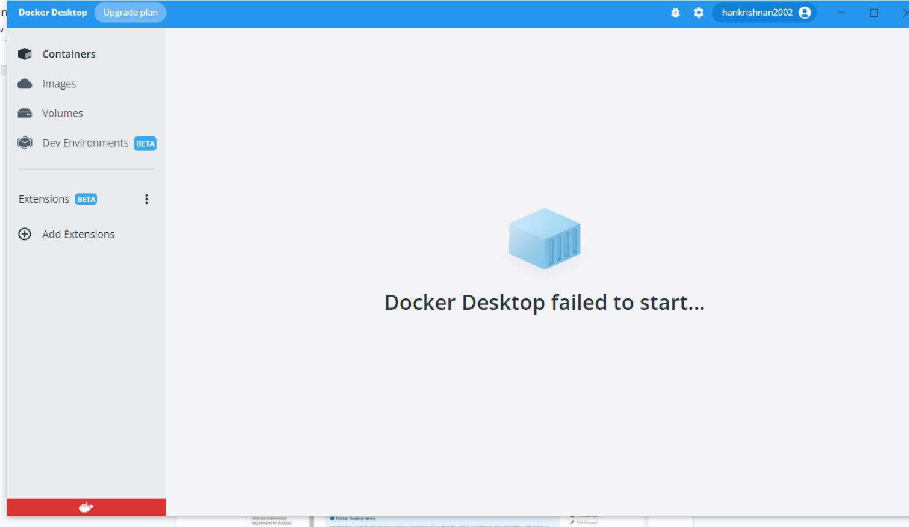

**Step 6:**

Finally, the docker is installed successfully.